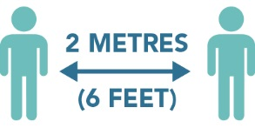
Please Maintain Physical Distancing

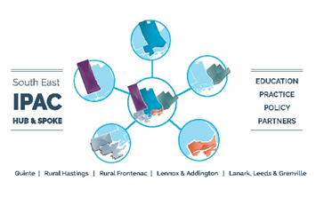
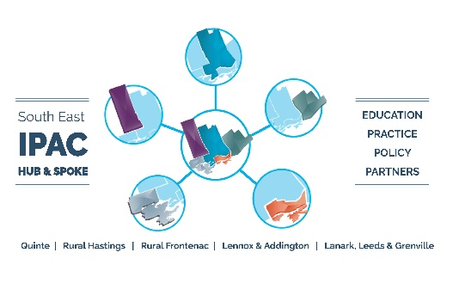
Maximum room occupancy:
Please keep a mask on at all times unless you are eating or drinking.
Put your mask on immediately after nourishment.
This space has been optimized for good physical distancing. Please observe the posted rules and do not move furniture.
Too many people in here? Try taking your break somewhere else or staggering your breaks.

3

